

**Green University of Bangladesh**

**Department of Computer Science and Engineering (CSE)**

**Faculty of Sciences and Engineering**

**Semester: (Summer, Year:2022), B.Sc. in CSE (Day)**

**Course Title : CSE Lab**

**Course Code: CSE 106 Section:DC**

**Lab Project Name: EMPLOYEE MANAGEMENT SYSTEM**

**Student Details**

| **Name** | **ID** |
| --- | --- |
| **Md. Shipon Miah** | **213902104** |

**Submission Date: 9/10/2022**

**Course Teacher’s Name: Md. Sultanul Islam Ovi**

**[For Teachers use only: Don’t Write Anything inside this box]**

| **Lab Project Status**  **Marks: ………………………………… Signature: .....................**  **Comments: .............................................. Date: ..............................** |
| --- |

Table of Contents

**Chapter 1 Introduction**

1.1 Introduction

1.2 Design Goals/Objective

**Chapter 2 Design/Development/Implementation of the Project**

2.1 Section (Choose the name of this section as appropriate with your project)

2.2 Section (Choose the name of this section as appropriate with your project)

2.2.1 Subsection

**Chapter 3 Performance Evaluation**

3.1 Simulation Environment/ Simulation Procedure

3.2 Results and Discussions

**Chapter 4 Conclusion**

4.1 Introduction

4.1 Practical Implications

4.2 Scope of Future Work

**References**

# Chapter 1 Introduction

## Introduction

Our main focus is to design a unique Employee Management system that will improve Data management in Institutes experience for Companies. The whole system will run on the internet. The system is written in C using data structure. Employee management system is a distributed application, developed to maintain the details of employees working organization. It maintains the information about the personal and official details of the employees.

## Design Goals/Objective

* This Project aims to simplify the task of maintaining records of the employees of Company.
* To develop an well-designed database to store employee information.
* Provide full functional reports to management of Company.

## PSEUDO CODE

## HEADER FILES & VARIABLES

# //EMPLOYEE MANAGEMENT SYSTEM PROJECT

# #include <stdio.h>

# #include <stdlib.h>

# #include <string.h>

# #include <math.h>

# #include <stdbool.h>

# #define TOTAL_EMP 100

# typedef struct

# {

# char name[50];

# int id;

# char address[20];

# double basic_salary;

# } Employee;

# int i = 0, n = 0;

# char choice;

# int read = 0, record = 0;

# FILE *file1, *file2;

# Employee emp[TOTAL_EMP];

# void fileload(Employee emp[])

# {

# file2 = fopen("hasan.txt", "w+");

# if (file2 == NULL)

# {

# printf("Error opening file2\n");

# exit(1);

# }

# do

# {

# read = fscanf(file2, "%39[^,],%d,%19[^,],%lf\n", emp[record].name, &emp[record].id, emp[record].address, &emp[record].basic_salary);

# if (read == 4)

# record++;

# if (read != 4 && !feof(file2))

# {

# printf("File format error\n");

# exit(1);

# }

# if (ferror(file2))

# {

# printf("Error reading from file2\n");

# exit(1);

# }

# }

# while (!feof(file2));

# fclose(file2);

# }

# void add_employee(Employee emp[])

# {

# file1 = fopen("file.txt", "w+");

# char another = 'y';

# while (another == 'y')

# {

# printf("\nEmployee %d info:\n", record + 1);

# fflush(stdin);

# printf("Enter Your Name: ");

# scanf("%[^\n]%*c", emp[record].name);

# fflush(stdin);

# printf("Enter Your id: ");

# scanf("%d", &emp[record].id);

# fflush(stdin);

# printf("Enter Your Address: ");

# scanf("%[^\n]%*c", emp[record].address);

# fflush(stdin);

# printf("Enter Your Salary: ");

# fflush(stdin);

# scanf("%lf", &emp[record].basic_salary);

# printf("\n");

# printf("Do you want to Add another Employee? (y/n): ");

# fflush(stdin);

# another = getchar();

# record++;

# }

# for (i = 0; i < record; i++)

# {

# fprintf(file1, "%s,%d,%s,%.2lf\n", emp[i].name, emp[i].id, emp[i].address, emp[i].basic_salary);

# if (ferror(file1))

# {

# printf("Error writing to file1\n");

# exit(1);

# }

# }

# fclose(file1);

# printf("\n%d Employee added Successfully to file1\n", record);

# }

# void list_employee(Employee employees[])

# {

# printf("%-7s %-20s %-7s %-20s %-10s\n", "Serial", "Name", "id", "Address", "Salary");

# for (i = 0; i < record; i++)

# {

# printf("%-7d %-20s %-7d %-20s %-10.2lf\n", i, emp[i].name, emp[i].id, emp[i].address, emp[i].basic_salary);

# }

# system("pause");

# }

# void modify_employee(Employee emp[])

# {

# printf("Enter the serial number of the employee you want to modify: ");

# fflush(stdin);

# scanf("%d", &n);

# printf("\nEmployee %d info:\n", n);

# fflush(stdin);

# printf("Name: ");

# scanf("%[^\n]%*c", emp[n].name);

# fflush(stdin);

# printf("id: ");

# scanf("%d", &emp[n].id);

# fflush(stdin);

# printf("Address: ");

# scanf("%[^\n]%*c", emp[n].address);

# fflush(stdin);

# printf("Basic Salary: ");

# fflush(stdin);

# scanf("%lf", &emp[n].basic_salary);

# printf("\n");

# file1 = fopen("CCsvf.csv", "w+");

# for (i = 0; i < record; i++)

# {

# fprintf(file1, "%s,%d,%s,%.2lf\n", emp[i].name, emp[i].id, emp[i].address, emp[i].basic_salary);

# if (ferror(file1))

# {

# printf("Error writing to file1\n");

# exit(1);

# }

# }

# printf("Employee %d modified\n", n);

# fclose(file1);

# system("pause");

# }

# void delete_employee(Employee emp[])

# {

# printf("Enter the employee serial number : ");

# fflush(stdin);

# scanf("%d", &n);

# for (i = n; i < record; i++)

# {

# strcpy(emp[i].name, emp[i + 1].name);

# emp[i].id = emp[i + 1].id;

# strcpy(emp[i].address, emp[i + 1].address);

# emp[i].basic_salary = emp[i + 1].basic_salary;

# }

# record--;

# file1 = fopen("CCsvf.csv", "w+");

# for (i = 0; i < record; i++)

# {

# fprintf(file1, "%s,%d,%s,%.2lf\n", emp[i].name, emp[i].id, emp[i].address, emp[i].basic_salary);

# if (ferror(file1))

# {

# printf("Error writing to file1\n");

# exit(1);

# }

# }

# fclose(file1);

# printf("Employee %d is deleted\n", n);

# system("pause");

# }

# void search_employee(Employee emp[])

# {

# int lb,ub,mid,id;

# lb=0,ub=record-1;

# printf("\nEnter id to search: ");

# scanf("%d",&id);

# while(lb<=ub)

# {

# mid = (lb+ub)/2;

# if (emp[mid].id==id)

# {

# printf("%-7s %-20s %-7s %-20s %-10s\n", "Serial", "Name", "id", "Address", "Salary");

# printf("%-7d %-20s %-7d %-20s %-10.2lf\n", i, emp[mid].name, emp[mid].id, emp[mid].address, emp[mid].basic_salary);

# fclose(file1);

# system("pause");

# }

# else if(emp[mid].id>id)

# ub = mid-1;

# else

# lb = mid + 1;

# }

# printf("\nEmploy is not found\n");

# }

# void sort_employee_By_salary(Employee emp[])

# {

# int i, j;

# Employee temp;

# for (i = 0; i < record; i++)

# {

# for (j = 0; j < record - 1; j++)

# {

# if (emp[j].basic_salary > emp[j + 1].basic_salary)

# {

# strcpy(temp.name, emp[j].name);

# temp.id = emp[j].id;

# strcpy(temp.address, emp[j].address);

# temp.basic_salary = emp[j].basic_salary;

# strcpy(emp[j].name, emp[j + 1].name);

# emp[j].id = emp[j + 1].id;

# strcpy(emp[j].address, emp[j + 1].address);

# emp[j].basic_salary = emp[j + 1].basic_salary;

# strcpy(emp[j + 1].name, temp.name);

# emp[j + 1].id = temp.id;

# strcpy(emp[j + 1].address, temp.address);

# emp[j + 1].basic_salary = temp.basic_salary;

# }

# }

# }

# file1 = fopen("shipon.text", "w+");

# for (i = 0; i < record; i++)

# {

# fprintf(file1, "%s,%d,%s,%.2lf\n", emp[i].name, emp[i].id, emp[i].address, emp[i].basic_salary);

# if (ferror(file1))

# {

# printf("Error writing to file1\n");

# exit(1);

# }

# }

# fclose(file1);

# printf("Employee sorted by salary\n");

# system("pause");

# }

# int main()

# {

# fileload(emp);

# while (1)

# {

# printf(" \n :::::::::::::::::::::::::: EMPLOYEES MANAGEMENT SYSTEM OF GUB :::::::::::::::::::::::::: \n");

# printf(" \t\t\t\t 1. Add Employee To Your Company\n");

# printf(" \t\t\t\t 2. Total Employee Your Have\n");

# printf(" \t\t\t\t 3. Update Employee Details\n");

# printf(" \t\t\t\t 4. Delete Employee Records\n");

# printf(" \t\t\t\t 5. Search Employee Form your Company\n");

# printf(" \t\t\t\t 6. Sort Employee Records\n");

# printf(" \t\t\t\t 7. Exit System \n");

# printf(" \n \n Your Choice: ");

# fflush(stdin);

# choice = getchar();

# switch (choice)

# {

# case '1':

# system("cls");

# add_employee(emp);

# break;

# case '2':

# system("cls");

# list_employee(emp);

# break;

# case '3':

# system("cls");

# modify_employee(emp);

# break;

# case '4':

# system("cls");

# delete_employee(emp);

# break;

# case '5':

# system("cls");

# search_employee(emp);

# break;

# case '6':

# system("cls");

# sort_employee_By_salary(emp);

# break;

# case '8':

# system("cls");

# exit(0);

# break;

# default:

# system("cls");

# printf("Invalid Choice");

# break;

# }

# }

# return 0;

# }

# Chapter 3 Performance Evaluation

## OUTPUT

**ENTER CHOICE**

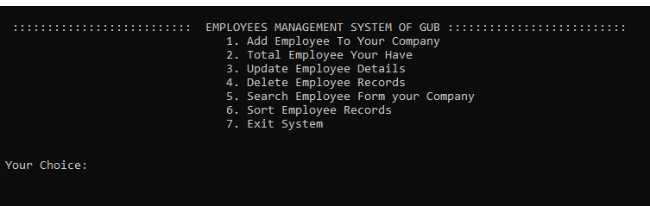

**ADD EMPLOY:**

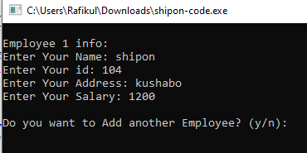

**Delete:**

## 

**SEARCH:**

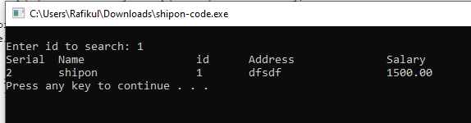

**UPDATE:**

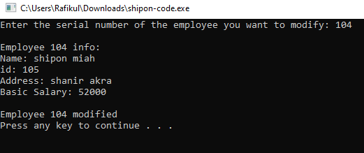

**SORT:**

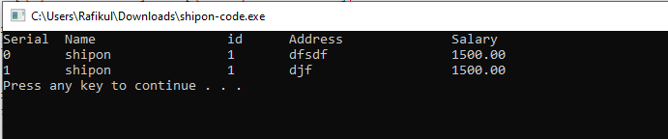

## 

## Results and Discussions

**Analysis and Outcome**

**It provides computerized system for maintaining records. More efficient and reliable. Less time consuming and easy to use. Its help for Companies to get a easy way to manage this problem. Easily see any employee detils. Easy to remove a employee form the company.**

# 

# Chapter 4 Conclusion

**Employee management systems makes makes more easy accessible by giving them an easy place to find and sort information. This system is help to save time by doing easily the work.**

# References

1. **Used google to get the basic structure of my code.**
2. **Got the idea for slideshare.com**
3. **Take help form classmats.**